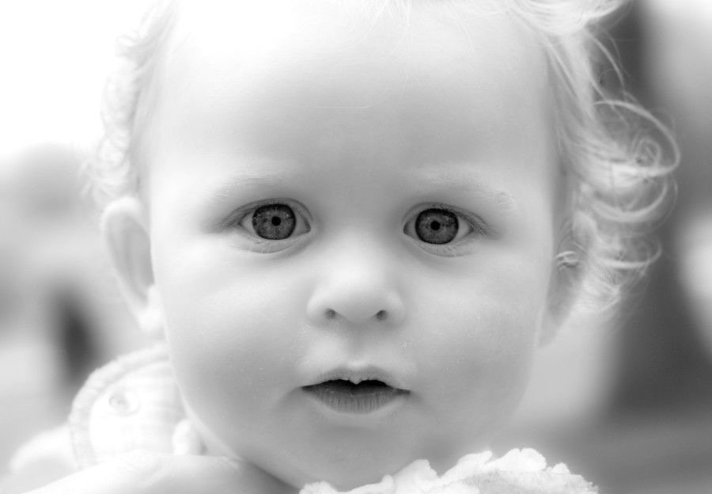

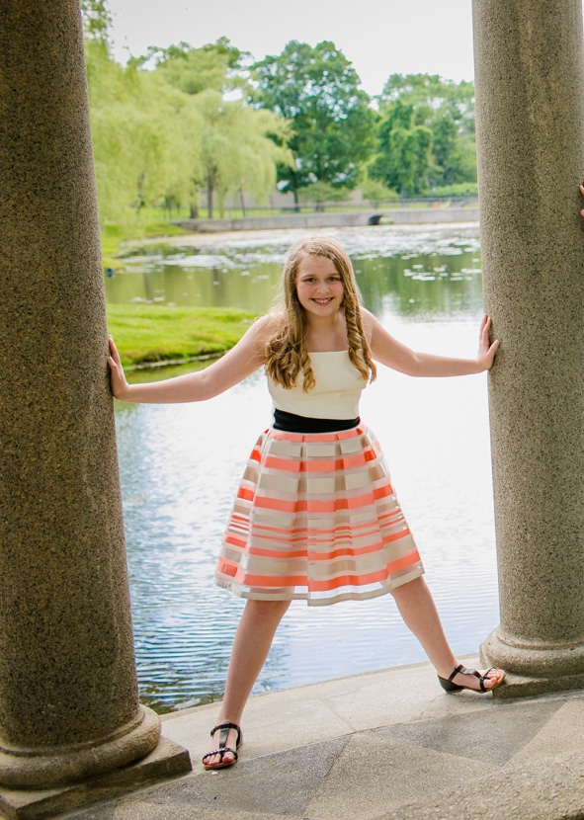

Welcome to the Bat Mitzvah of

Carly Elizabeth Grossman

חַיָה עַלִיזָה

June 25th, 2016

19th of Sivan, 5776

Congregation Kehillath Israel
Brookline, Massachusetts
Our Deepest Thanks!

We are delighted that our family and friends are here to share this special day with us. Following today’s service, everyone is invited to Kiddush in Epstein Hall.

We would like to thank Rabbi Hamilton, Rabbi Silverman and all of the staff at Kehillath Israel for their help and support throughout this process. A special thanks to Carly’s Torah Tutor, Gaby Avery-Peck, for her knowledge and guidance in helping Carly prepare for today.

Shabbat Shalom.
Brian, Marci, Carly, Max, and Eden

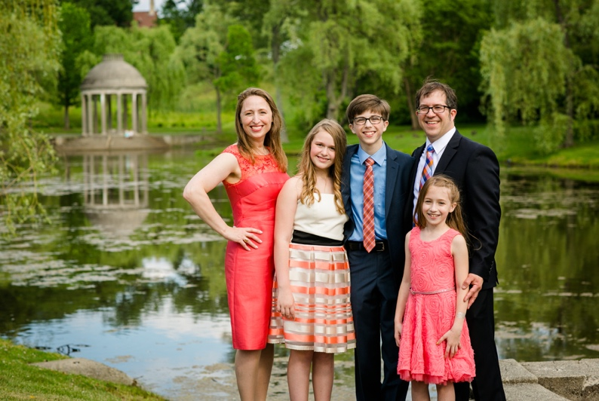

Carly is always up for an adventure. If you want someone to join you on a road trip or try a new restaurant, you can always count on Carly.

Even at a young age, Carly was a deep thinker. Normal discussions are often peppered with doozies like "Would you rather have hair nowhere on your body or be very hairy all over and not be able to shave?" or "Would you rather be stranded on an island alone or with someone you hate?"

While at first, Carly seems somewhat shy. As you get to know her, you realize she's nuts. Pure craziness. She'll keep you on your toes with her outlandish antics. When she's getting to know you, she'll be sure to assess your threshold for her 'offbeat' humor.

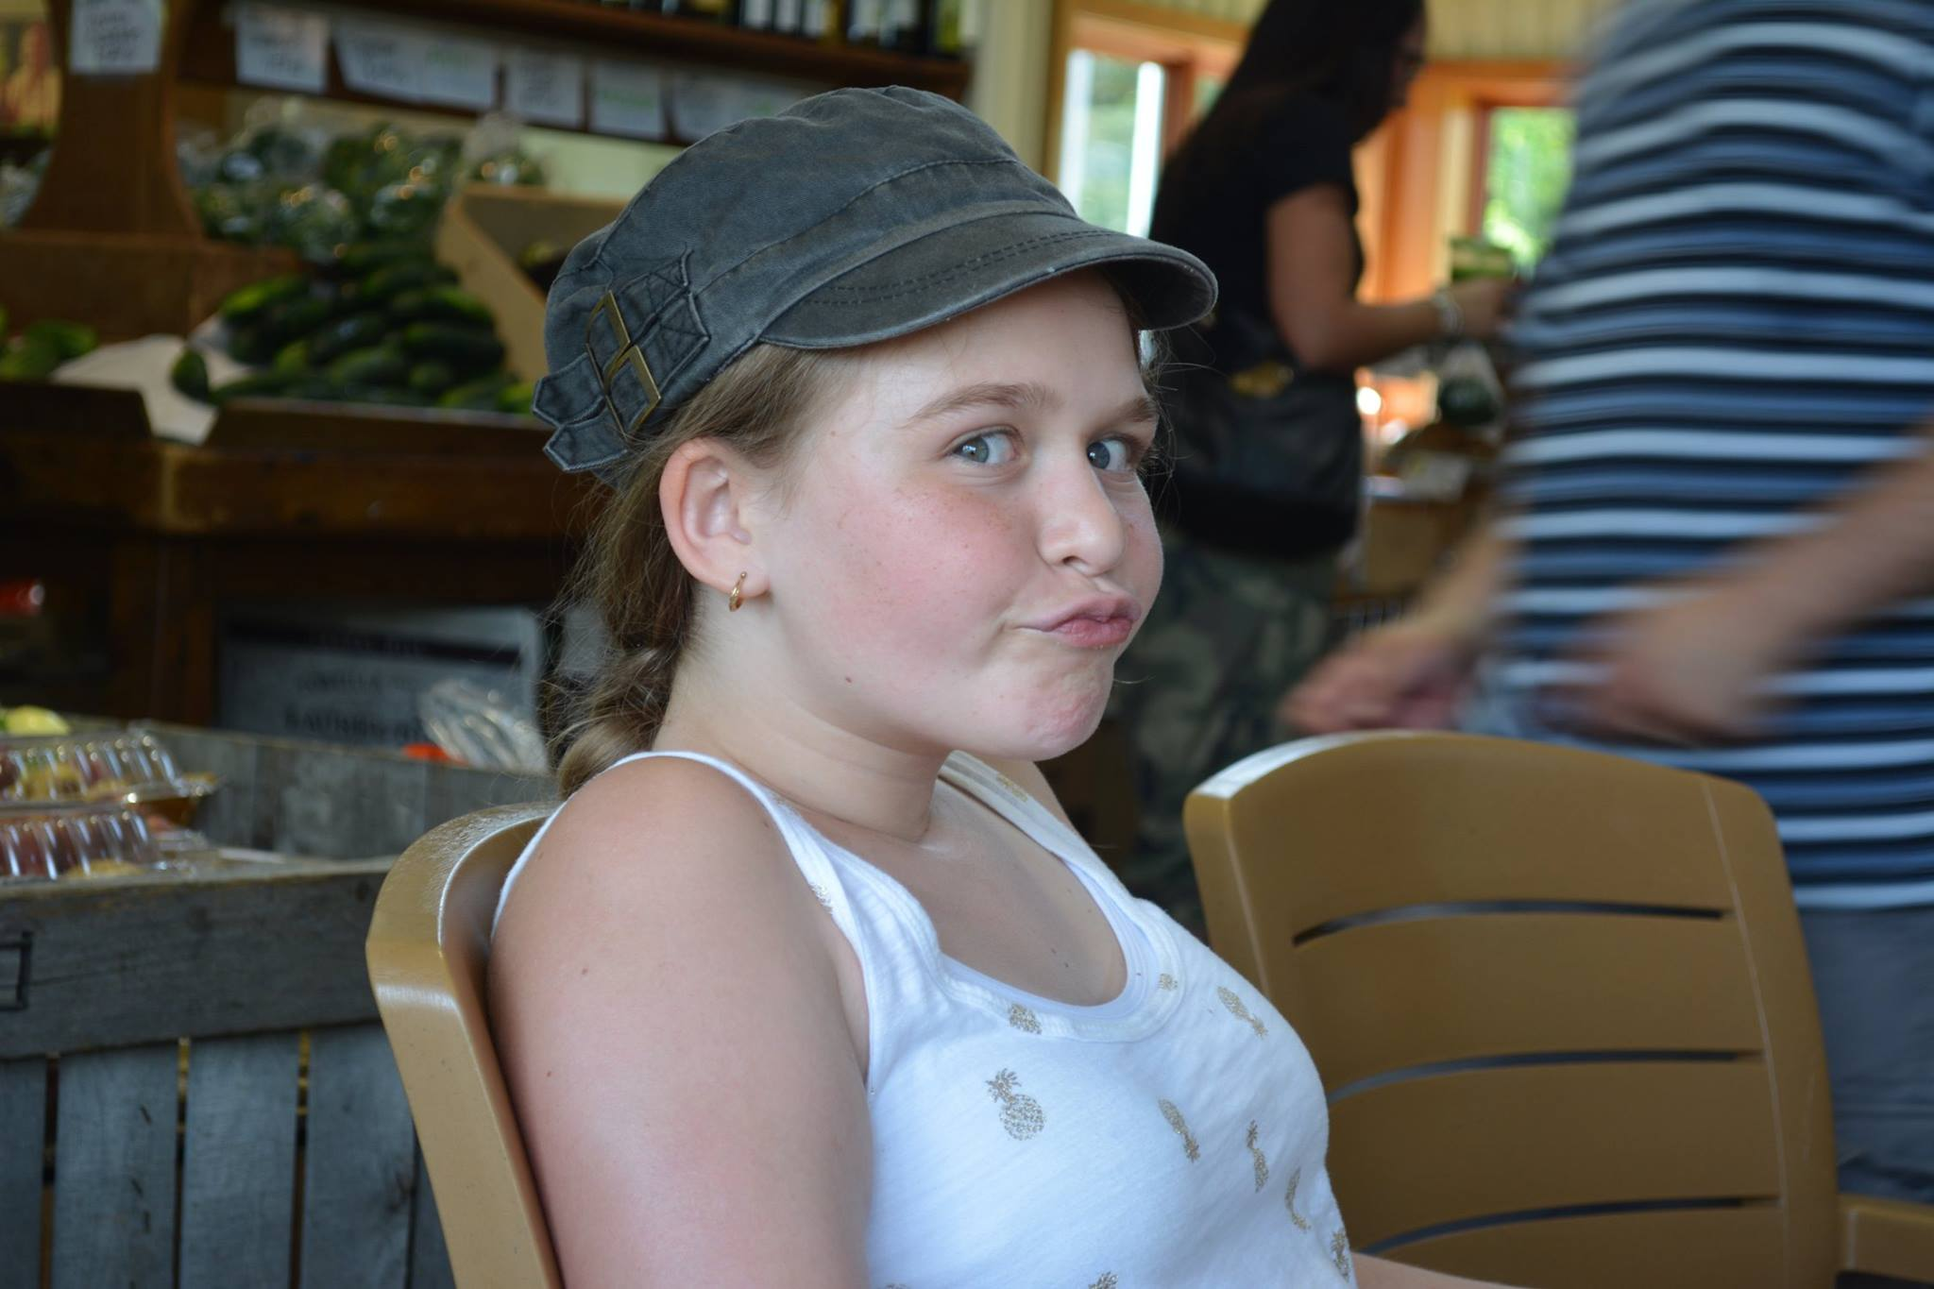

Carly is blessed with artistic talent and a good eye. Whether it's a project for school, a photograph, or just a doodle on a scrap of paper, everything she creates is sure to captivate.
Welcome!

We are so happy you are able to join us today for Carly’s Bat Mitzvah. It’s an incredibly special milestone for Carly and our family. Whether this is your first Bat Mitzvah or your hundredth, we want you to feel included and understand what’s happening.

About Carly

Carly’s Hebrew name (Chaya Aliza) means “happy life” and we wish Carly a life befitting of her name. Carly is always fun to have around the house. Not a day goes by when she doesn't have each member of the family in stitches. Along with her great sense of humor, Carly commits 100% to everything she does. This includes everything from her school work to playing the piano, to creating custom birthday cards for family and friends.

Carly was given her middle name, Elizabeth, in honor of her great-grandmother, Elaine, on her father's side. Like Carly, Elaine was a very talented and capable woman. Everything she did, whether cooking delicious meals or knitting complex afghans, she did with impressive skill.
What’s a Bat Mitzvah All About?

Bat Mitzvah translates as “Daughter of the Commandments.” What this means is that Carly will now be accountable for her actions as a young Jewish adult, which includes following the laws and guidance of the Torah (Bible). This is the expectation of all Jewish girls when they reach the age of 12 or 13. For Jewish boys, they celebrate their Bar Mitzvah at 13 years old. A central part of a Bat Mitzvah ceremony, includes being called to read aloud from the Torah for the first time. Carly will be chanting the first and final portions of today’s Torah reading (Behaalotcha) to mark this occasion. She will also be sharing some thoughts on the Torah portion as well as chanting the Haftarah (Zechariah) and leading some prayers throughout the service.

Phones and Shabbat

Phones and cameras are not permitted at Kehillath Israel during the Sabbath. We ask that you kindly keep your phone shut off and away while at the synagogue.

What to Wear?

In our Synagogue, it is customary for all men to wear a Kippah (yarmulke) on their heads and Jewish men are expected to wear a Tallit (prayer shawl). Jewish women often cover their heads and wear a Tallit, as well. Both are available in the foyer of the sanctuary for your use.
Carly-isms

If you ever want to keep a secret, make sure Carly is not in the same zip code. Many times one of us has whispered a secret to someone only to hear Carly call out "I heard that!" from across the house.

Carly has tremendous “sticktoitiveness.” Once she starts something, she almost always sees it through to completion.

Carly has always been easy going. She goes with the flow and rarely gets rattled. As general rule, this is an amazing quality, except when it comes to getting out of the car. It takes that girl forever to exit the vehicle. FOREVER.

When it comes to food, Carly will try anything, whether it's joining Dad at a ramen pop-up or tasting a concoction whipped up by her brother (don't ask). But somehow, she doesn't like soda or frosting.

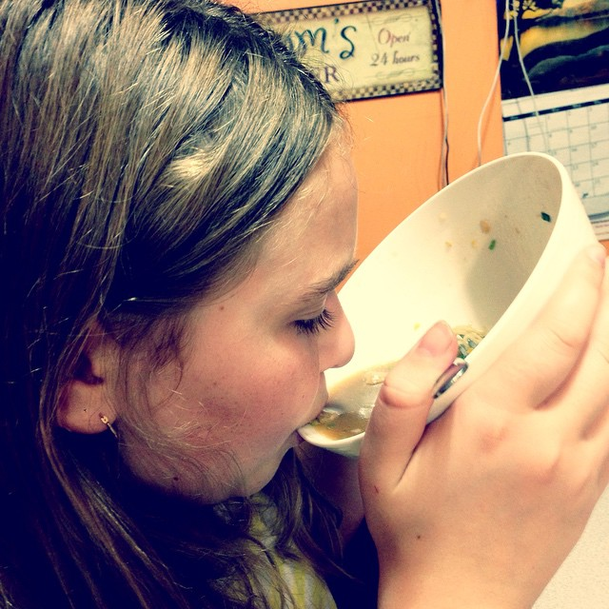
D’VAR TORAH | A speech that incorporates some teaching from the Torah. Carly will share a D’var Torah with us today based on her studies of the Behaalotcha Torah portion.
HAFTARAH | A series of selections from the books of Nevi'im ("Prophets") publicly read in synagogue following the Torah reading each Sabbath and on Jewish festivals and fast days. Typically, the Haftarah is thematically linked to the Torah portion that precedes it. According to ancient legend, Jews were prevented from reading Torah in the 2nd century BCE. Our ancestors evaded the ruling by reading passages from the prophets instead, which reminded of the corresponding Torah readings. Today, Carly will read the Haftarah portion, “Zechariah.”
SIDDUR | The Jewish prayer book, taken from the word meaning “order.” The services are organized in a purposeful sequence within this book. You will find the green book at your seats to follow along. As Hebrew is written and read from right to left, the books open this way.
CHUMASH | The written form of the Torah (vs. scroll). It comes from the Hebrew word “Chamesh” which means “five,” as it includes the 5 books of Moses. You can follow as Carly chants from the Torah and Haftarah portions in the red Etz Hayim Chumash.
About the Service

Services in Judaism are a communal experience that requires a minyan (quorum) of ten adults. As a Bat Mitzvah, Carly can now be included in the minyan.

The Torah Service is at the heart of the Sabbath morning service. The Torah, consisting of the Five Books of Moses, represents all the laws and teachings of Jewish tradition. A specified portion, called a parashah is read aloud every week, with the whole Torah being completed over a year’s time. In synagogues all over the world, this same parashah is being read today. This week’s Torah portion is called, Behaalotcha, from the Book of Numbers, found on page 816 in the red Etz Hayim Chumash.

The public reading of the Torah dates from the practice in the ancient Temple of Jerusalem. The scrolls are inscribed by hand on parchment, as they have been for millennia. They are written in a distinct script, without the vowels, punctuation or cantillation notations that are in the Bible at your seat. Chanting Torah, takes extra training, skill and musical memory.

Carly will be reciting the first and last (Maftir) portions, of today’s parashah. Additionally, Marci, Carly’s mother, will chant the 2nd portion/aliya. Carly’s Torah Tutor, Gaby Avery-Peck, will be chanting the 6th and 7th portions/aliyot. After reading from the Torah, Carly will share her thoughts on the Torah portion (D’var Torah). She will then chant from Zechariah in the Haftarah found on page 837 of the red Etz Hayim Chumash.

Honors

It is an honor to assist in all aspects of the Torah service, and several of Carly’s family members and friends will be honored today.

Ark Opening | Rachel Grossman (Aunt) &  Derek Beaulieu
Torah Carrier | Carly Grossman (Bat Mitzvah)
First Aliyah (Cohen) | Chanted by Carly Grossman
Second Aliyah (Levi) | Larry & Jane Levine (Grandparents) / Chanted by Marci Grossman (Mother)
Third Aliyah | Sonny Grossman (Grandparent)
Fourth Aliyah | Cheryl & Abe Heitin (Grandparents)
Fifth Aliyah | Lenny & Helena Levine (Uncle/Aunt)
Sixth Aliyah | Max Grossman (brother) / Chanted by Gaby Avery-Peck (Teacher)
Seventh Aliyah | Brian & Marci Grossman (Parents) / Chanted by Gaby Avery-Peck (Teacher)
Final/”Maftir” Aliyah | Chanted by Carly Grossman (Bat Mitzvah)
Hagbah | Bill Heitin (Uncle)
Gelilah | Suzanne Heitin (Aunt)
Haftarah | Chanted by Carly Grossman (Bat Mitzvah)
Prayer for Israel | Julia Heitin (Cousin)
Prayer for U.S.A. | Shannon Haglund (Friend)
Torah Carrier | Carly Grossman (Bat Mitzvah)
Ark Opening | Ed, Henry, and Nat Heitin (Uncle/Cousins)
Ark Opening | Carly Grossman, Eleanor Reyelt,  Tilde Jaques, Maeve Laslie (friends)
Shir HaKavod | Eden Grossman (Sister)
Ein Keloheinu | Max, Eden, Carly
Adon Olam | Carly, Max and Eden Grossman  and their cousins
Terms to Note

BIMAH | The raised platform at the front of the sanctuary where you will find the Holy Ark.
ARON KODESH | The Holy Ark contains our Torah Scrolls - the most sacred objects of our faith. Each time the Ark is opened, or the Torah Scrolls are lifted, we all stand in respect.
GABBAI | A person who helps to run the services in synagogue. Typically there are two. For example, today you will see two people on either side of the Torah, to help unroll the scroll and guide the reader, as needed.
ALIYA | Each time a portion of the Torah is read, a person is honored by coming up to the Torah and reciting a blessing before and after the portion. Traditionally, the 1st aliya goes to a Cohen, or a descendant of the priestly family. The 2nd aliya goes to a Levi, or a descendant of the Levite family. The remaining aliyot are open to any Jewish person over the age of Bat or Bar Mitzvah.
HAGBAH | After the Torah is read, a member of the community lifts it into the air and displays it for all to see.
GELILAH | This person wraps the Torah following the proper procedure and prepares it to return to the ark.

