Max has decided to donate a portion of his Bar Mitzvah gifts to Dana-Farber Cancer Institute.

In addition, the centerpieces at our luncheon will be donated to Cradles to Crayons.


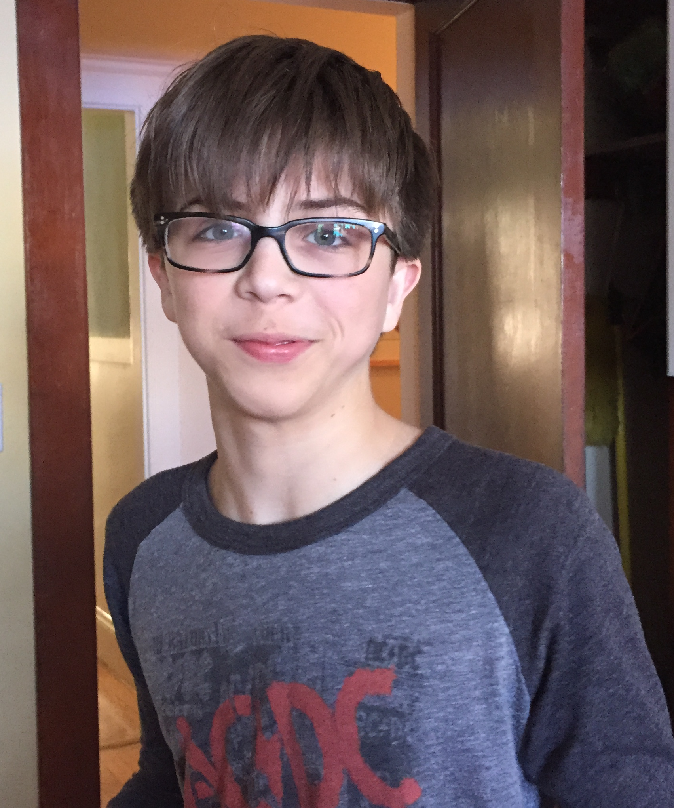

Welcome to the Bar Mitzvah of

Maxwell Louis Grossman
לֵב חֵםמְנַ

June 20th, 2015

3rd of Tammuz, 5775

Congregation Kehillath Israel
Brookline, Massachusetts
Our Deepest Thanks!

We are delighted that our family and friends are here to share this special day with us. Following today’s service, our guests are invited to a Kiddush luncheon in Epstein Hall.

Please note that the Congregational Kiddush will be held downstairs in Landers Hall.

We would like to thank Rabbi Hamilton, Rabbi Silverman and all of the staff at Kehillath Israel for their help and support throughout this process. A special thanks to Max’s Torah Tutor, Gaby Avery-Peck, for her knowledge and guidance in helping Max prepare for today.

Shabbat Shalom.
Brian, Marci, Max, Carly, and Eden

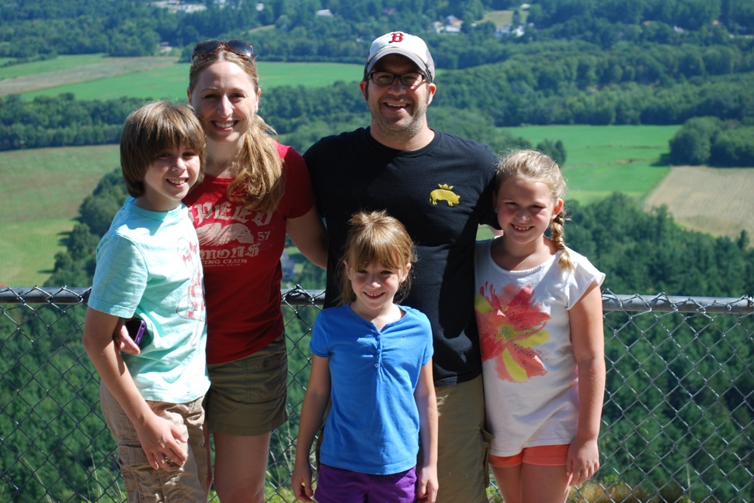

When some children were little, they were comforted by sleeping with their favorite stuffed animal. Max slept with a set of plastic cutlery, a regulation size soccer ball, a Harry Potter Lego set and a wall clock.

The human metronome, Max's drumming skills were discovered at the age of five when he was found smacking the radiator with Tinker Toys… but there were earlier signs …

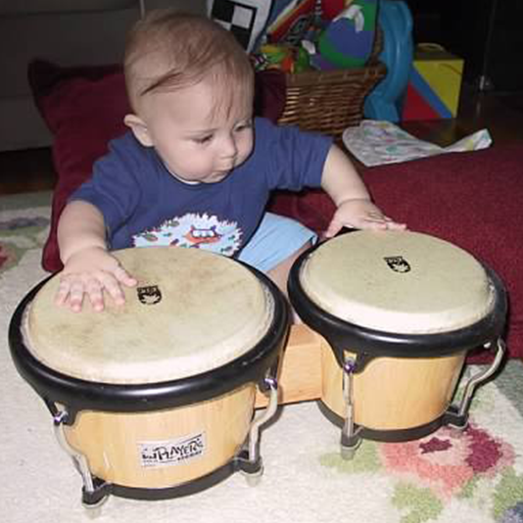

A great sharer, if Max is eating something that he knows you like, he will always save you a bite. Always.
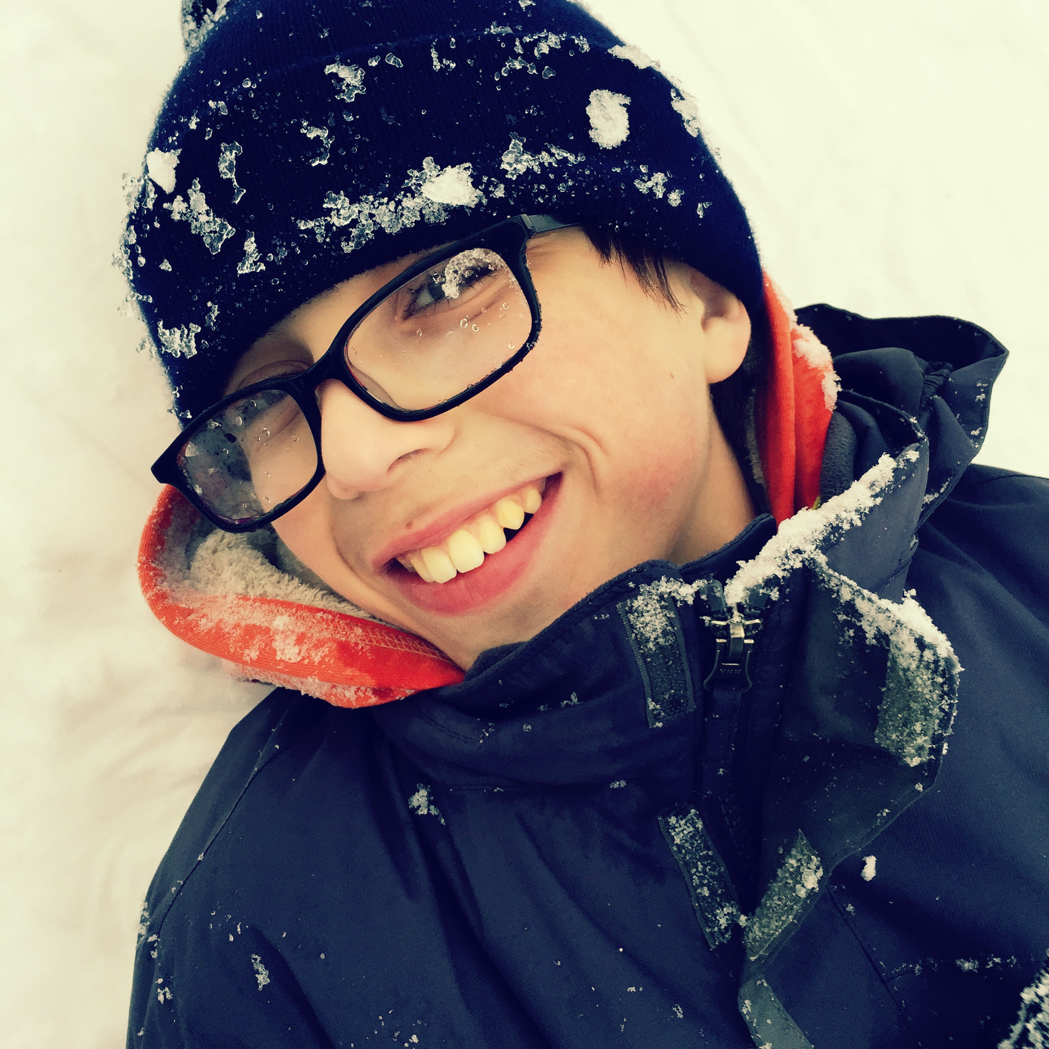
Do you know that lobsters don't die of old age? Do you know that cheetahs can change direction in mid air? Do you know that the pistol shrimp shoots a vacuum cavitation bubble almost as hot as the sun from its claw? Max does.

Max enjoys puzzles, inventing and building. With help from the folks at Eureka! Puzzles, we have tried to infuse this essence into his Bar Mitzvah.
Welcome!

We are so happy you are able to join us today for Max’s Bar Mitzvah. It’s an incredibly special milestone for Max and our family. Whether this is your first Bar Mitzvah or your hundredth, we want you to feel included and understand what’s happening.

About Max

Max’s Hebrew name (Menachem Lev) means “one who comforts the heart.” Max has brought us tremendous joy and pride in his 13 years. He has a sweet, kind soul and a clever, inventive mind. He has an appetite for good (and sometimes bad) humor and enjoys spending time with friends and family – whether in person or online. He is passionate, curious, creative, humble and genuine. Max is also an accomplished drummer – taking lessons since he was in first grade, he and his “Pop Rox” bandmates have been playing together for three years.

Max is named after three great-grandfathers – Barney Levitt, Mike Grossman and Louis Gamm. Barney was a joker with a larger-than-life personality. Mike was a kindhearted, soft-spoken man. Louis was a hard working family-man who was happy with the simplest pleasures. We are grateful that Max embodies qualities from each of these wonderful men.
What’s a Bar Mitzvah All About?

Bar Mitzvah translates as “Son of the Commandment.” What this means is that Max will now be accountable for his actions as a young Jewish adult, which includes following the laws and guidance of the Torah (Bible). This is the expectation of all Jewish boys when they reach the age of 13. For Jewish girls, they can celebrate their Bat Mitzvah at either 12 or 13 years old. A central part of a Bar Mitzvah ceremony, includes being called to read aloud from the Torah for the first time. Max will be chanting the final portion of today’s Torah reading (Korach) to mark this occasion. He will also be sharing some thoughts on the Torah portion as well as chanting the Haftarah (Samuel) and leading some prayers throughout the service.

Phones and Shabbat

Phones and cameras are not permitted on Shabbat. We ask that you kindly keep your phone shut off and away while you are at the synagogue today.

What to Wear?

In our Synagogue, it is customary for all men to wear a Kippah (yarmulke) on their heads and Jewish men are expected to wear a Tallit (prayer shawl). Jewish women often cover their heads and wear a Tallit, as well. Both are available in the foyer of the sanctuary for your use.
Max-isms

You will never meet anyone who eats food more carefully and neatly than Max. This includes hamburgers, tacos and ice cream cones.

You will never meet anyone who has a messier room than Max. This includes a 12-pack of empty soda cans, an archeological dig site of old electronics projects and, we think, proof of the existence of the Loch Ness Monster.

When Max hears a song, he has the uncanny ability to not only identify the movie it's from, but the exact scene... after only hearing it once.

Technology has evolved Max into the ultimate multi-tasker. Headphones on, so he can play Counter-Strike while Skyping with friends, ear buds inside the headphones, so he can consume the TV shows Psych and Kyle XY, seasons at a time… all while he does his homework.
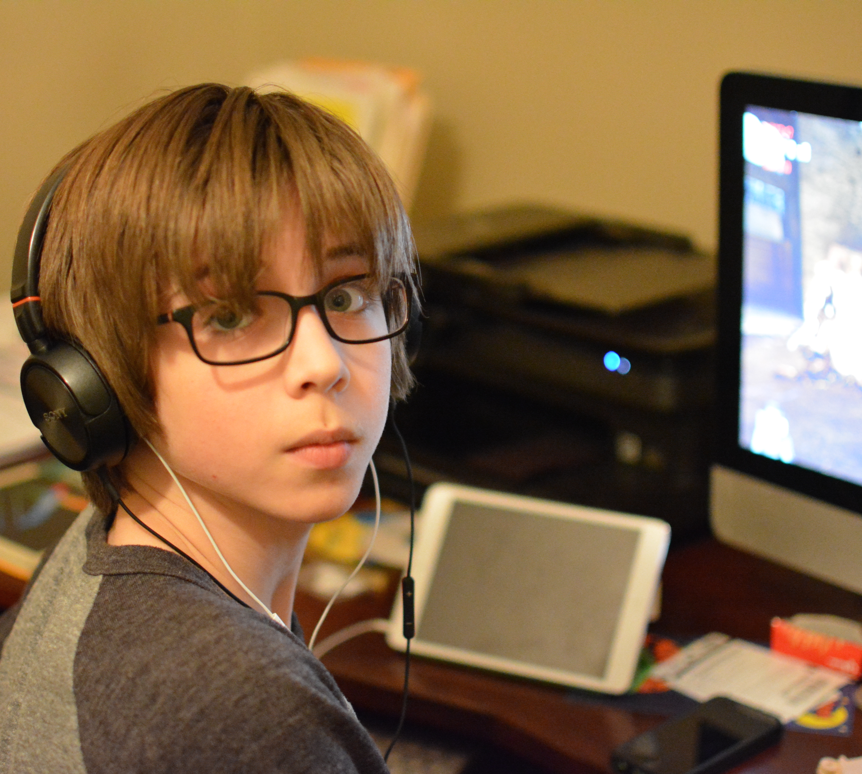
D’VAR TORAH | A speech that incorporates some teaching from the Torah. Max will share a D’var Torah with us today based on his studies of the Korach Torah portion.
HAFTARAH | A series of selections from the books of Nevi'im ("Prophets") publicly read in synagogue following the Torah reading each Sabbath and on Jewish festivals and fast days. Typically, the Haftarah is thematically linked to the Torah portion that precedes it. According to ancient legend, Jews were prevented from reading Torah by decree of the Syrian Hellenistic king, Antiochus IV in the second century BCE. Our ancestors evaded the ruling by reading passages from the prophets instead, which reminded of the corresponding Torah readings. Today, Max will read the Haftarah portion, “Samuel.”
SIDDUR | The Jewish prayer book, taken from the word meaning “order.” The services are organized in a purposeful sequence within this book. You will find the green book at your seats to follow along. As Hebrew is written and read from right to left, the books open this way.
CHUMASH | The written form of the Torah (vs. scroll). It comes from the Hebrew word “Chamesh” which means “five,” as it includes the 5 books of Moses. You can follow along as Max chants from the Torah or the Haftarah portion in the red Etz Hayim Chumash in your seat pockets.
About the Service

Services in Judaism are a communal experience that requires a minyan (quorum) of ten adults. As a Bar Mitzvah, Max can now be included in the minyan.

The Torah Service is at the heart of the Sabbath morning service. The Torah, consisting of the Five Books of Moses, represents all the laws and teachings of Jewish tradition. A specified portion, called a parashah is read aloud every week, with the whole Torah being completed over a year’s time. In synagogues all over the world, this same parashah is being read today. This week’s Torah portion is called, Korach, from the Book of Numbers, found on page 860 in the red Etz Hayim Chumash.

The public reading of the Torah dates from the practice in the ancient Temple of Jerusalem and was the main instrument for educating the people and strengthening their faith. The scrolls are inscribed by hand on parchment, as they have been for millennia. They are written in a distinct script, without the vowels, punctuation or cantillation notations that are in the Bible at your seat. Chanting the Torah, takes extra training, skill and musical memory.

Max will be reciting the Maftir, or ending portion, of today’s parashah. Additionally, Marci, Max’s mother (who recited from the same parashah at her Bat Mitzvah many years ago), will chant the 1st portion/aliya. Max’s Torah Tutor, Gaby Avery-Peck, will be chanting the 2nd and 3rd portions/aliyot. After reading from the Torah, Max will share his thoughts on the Torah portion (D’var Torah). He will then chant from Samuel in the Haftarah found on page 877 of the red Etz Hayim Chumash.

Honors

It is an honor to assist in all aspects of the Torah service, and several of Max’s family members and friends will be honored today.

Ark Opening | Gaby Avery-Peck (Teacher)
Torah Carrier | Max Grossman (Bar Mitzvah)
First Aliyah (Cohen) | Chanted by Marci Grossman (Mother)
Second Aliyah (Levi) | Larry & Jane Levine (Grandparents) /  Chanted by Gaby Avery-Peck (Teacher)
Third Aliyah | Sonny & Barrie Grossman (Grandparents) / Chanted by Gaby Avery-Peck (Teacher)
Fourth Aliyah | Cheryl & Abe Heitin (Grandparents)
Fifth Aliyah | Rachel Grossman (Aunt)
Sixth Aliyah | Lenny & Helena Levine (Uncle/Aunt)
Seventh Aliyah | Brian & Marci Grossman (Parents)
Final/”Maftir” Aliyah | Chanted by Max Grossman
Hagbah | Bill Heitin (Uncle)
Gelilah | Suzanne Heitin (Aunt)
Haftarah | Chanted by Max Grossman
Prayer for Israel | Marni & Julia Heitin (Cousins)
Prayer for U.S.A. | Shannon Haglund (Friend)
Torah Carrier | Max Grossman (Bar Mitzvah)
Ark Opening | Matty, Sydney, Dana Levine (Cousins)
Ark Opening | Zeke Frankl, Lawson Miller,  Scott Pittman (“Pop Rox”)
Shir HaKavod | Carly Grossman (Sister)
Ein Keloheinu | Eden Grossman (Sister)
Adon Olam | Max, Carly, Eden Grossman  and their cousins
Terms to Note

BIMAH | The raised platform at the front of the sanctuary where you will find the Holy Ark.
ARON KODESH | The Holy Ark contains our Torah Scrolls - the most sacred objects of our faith. Each time the Ark is opened, or the Torah Scrolls are lifted, we all stand in respect.
GABBAI | A person who helps to run the services in synagogue. Typically there are two. For example, today you will see two people on either side of the Torah, to help unroll the scroll and guide the reader, as needed.
ALIYA | Each time a portion of the Torah is read, a person is honored by coming up to the Torah and reciting a blessing before and after the portion. Traditionally, the first aliya goes to a Cohen, or a descendant of the priestly family. The second aliya goes to a Levi, or a descendant of the Levite family. The remaining aliyot are open to any Jewish person over the age of Bar or Bat Mitzvah.
HAGBAH | After the Torah is read, a member of the community lifts it into the air and displays it for all to see.
GELILAH | This person wraps the Torah following the proper procedure and prepares it to return to the ark.

